2. HASH FUNCTION – SHA-512
Aim
To implement the SHA-512 hash function using Python and generate the hash value for a given message.
Algorithm
- Import the hashlib module.
- Read the message from the user.
- Convert the message into bytes.
- Apply the SHA-512 hash function using hashlib.sha512().
- Convert the hash into hexadecimal format.
- Display the original message and SHA-512 hash value.
Program
import hashlib
message = input("Enter the message: ")
sha512_hash = hashlib.sha512(message.encode()).hexdigest()
print("Original Message:", message)
print("SHA-512 Hash:", sha512_hash)
Output:
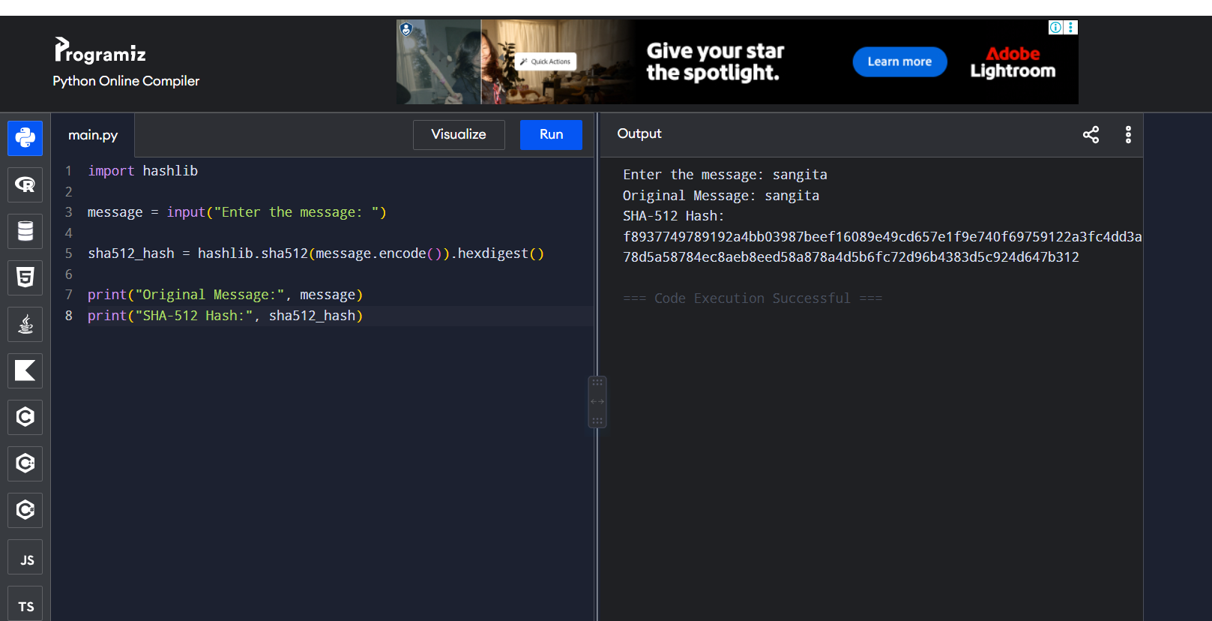
Result
The SHA-512 hash of the given message was successfully generated.

